Waterboy & Firegirl Manual

Contents

Setup 2

Components 2

Setup 2

How to play 3

Before playing 3

Playing levels 3

Functionalities & settings 4

Buttons 4

Levers 4

Liquids 4

Platforms 4

Diamonds 5

Finish 5

Settings 5

Controls 6

Menu 6

Joystick 6

C-button 6

Z-button 6

Game 6

Joystick 6

C-button 6

Z-button 6

# Setup

## Components

The package contains **two** of each component:

An Arduino Uno: A game shield:

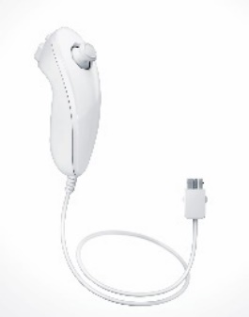

An LCD screen: A Wii Nunchuk:

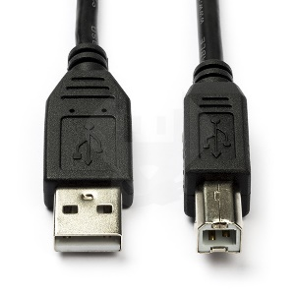And a USB-B cable:

## Setup

1. Place the Arduino on a hard surface.
2. **Carefully** push the pins of the Game Shield in the Arduino. Make sure you orient the Game Shield correctly before pushing it in.
3. **Carefully** push the pins of the LCD screen in the Game Shield. Make sure you orient the LCD screen correctly before pushing it in.
4. A picture containing electronics

   Description automatically generatedConnect the Wii Nunchuk to the Game Shield like this:
5. Finally, connect the USB-B cable to the Arduino and a 5 volt power source (like a power bank).
6. Repeat all these steps for the second Arduino.

# How to play

## Before playing

1. Place the Arduini across from each other and both have the Wii Nunchuk on your right side.
2. Turn on both Arduini by connecting them to a power source.
3. Both players choose the appropriate receiver type. (56KHz or 38KHz) You can find your type on the Game Shield.
4. Both players go into the “Play” menu where you can see the levels.
5. Player 1 (the player with the 38KHz receiver) will then be able to choose a level to play.
6. Player 1 has selected a level and both players enter the chosen level.

## Playing levels

1. The goal of all levels is for both players to get to the finish as fast as possible.
2. The players have to work together to overcome certain obstacles.
3. The score is determined by the time that is left and the number of diamonds collected at the end of a level.
4. When a level is finished, the next level will unlock.

# Functionalities & settings

## Buttons

A button activates when a character stands on top of it and it deactivates when a character steps off.

When activated, the connected platforms will move to their end position.

When deactivated, the connected platforms will move to their start position.

Sometimes buttons are connected to other buttons.

If a button is connected to another one, the connected platform will only deactivate when both buttons are deactivated.

You can tell which buttons are connected by looking at their colour, if they have the same colour they are connected to each other.

## A picture containing chart Description automatically generatedLevers

A lever toggles when a character stands on top of them, but doesn’t toggle when a character steps off.

When toggled on, the connected platforms will move to their end position.

When toggled off, the connected platforms will move to their start position.

## Liquids

Liquids come in 3 variations: Swamp gunk (green), Water (blue) and Lava (red).

A player can walk through a liquid if it has the same colour palette as the player.

None of the players can walk through the Swamp gunk.

If a player walks through a liquid that isn’t supposed to be touched by the player, both players lose a life and restart the level.

## Platforms

Platforms are movable with buttons and switches.

Platforms are connected to buttons or switches with the same colour.

Platforms with the same colour will move at the same time.

## Chart Description automatically generatedDiamonds

Players can collect diamonds by touching them.

A player is only able to collect diamonds of the same colour as the player.

Collecting a diamond will add 30 points to the score (max score = 255).

## Shape Description automatically generated with medium confidenceFinish

To finish a level both players need to stand at their door.

The doors are distinguishable by their colour and sign.

## Settings

If you accidentally choose the wrong receiver type during the setup phase you can always change it in the settings menu.

# Controls

## Menu

### Joystick

Up: Move the cursor up by 1.

Down: Move the cursor down by 1.

### C-button

Click: Enter.

### Z-button

Click: Back.

## Game

### Joystick

Left: Move the character left.

Right: Move the character right.

### C-button

Click: Let the character jump.

### Z-button

Click: Go back to the level select menu. (only player 1)